Project Design Phase-II
Technology Stack (Architecture & Stack)

Date | 31 January 3035
Team ID | SWTID-2026-3138
Project Name | ComicCraft - AI Comic Story Creator using Gemini Models
Maximum Marks | 4 Marks
Technical Architecture:
The architectural diagram of ComicCraft and the information as per Table-1 and Table-2 are given below.
Application: AI-powered comic story creator (story prompt to illustrated comic with PDF export)
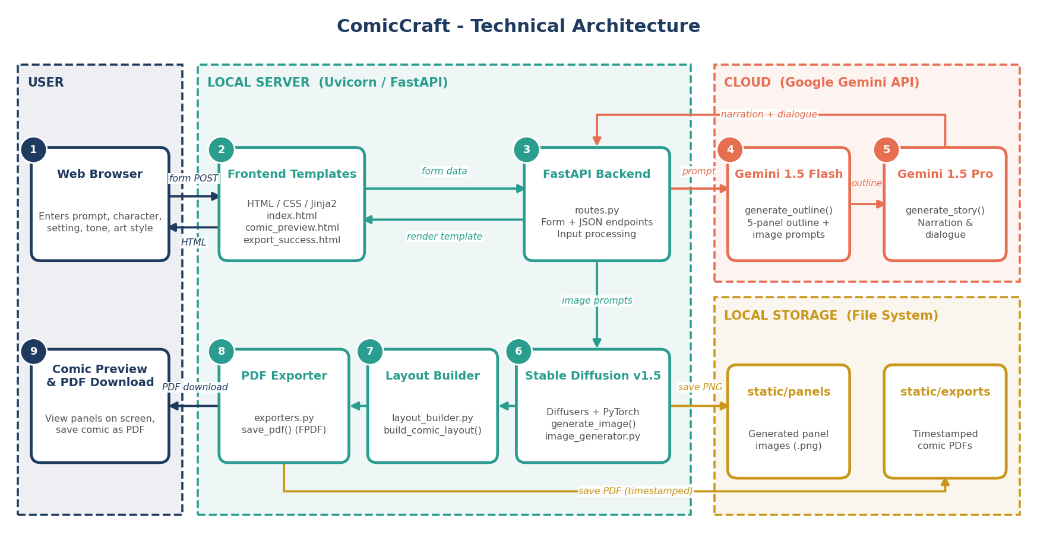
Table-1 : Components & Technologies:
S.No | Component | Description | Technology
1 | User Interface | Web UI where the user enters the story prompt, character name, setting, tone and art style, previews the generated comic panels and triggers the PDF download. | HTML, CSS, Jinja2 templates (index.html, comic_preview.html, export_success.html)
2 | Application Logic-1 | Request handling and routing: receives form / JSON input, coordinates the generation workflow, renders templates and confirms export. | Python, FastAPI (routes.py), Uvicorn ASGI server
3 | Application Logic-2 | Story generation: Gemini Flash creates a structured 5-panel outline with image prompts (generate_outline); Gemini Pro expands it into narration and dialogue (generate_story). | Google Gemini 1.5 Flash and 1.5 Pro via google-generativeai (gemini_flash.py, gemini_pro.py)
4 | Application Logic-3 | Comic assembly and export: matches each panel image with its story text (build_comic_layout) and compiles the comic into a multi-page PDF (save_pdf). | Python, FPDF, Pillow (layout_builder.py, exporters.py)
5 | Database | No persistent database is used. Outline, story and layout data are held in memory (lists / dictionaries) for each request. | Python in-memory data structures
6 | Cloud Database | Not used in the current version. | N/A
7 | File Storage | Generated panel images are saved to static/panels and exported comic PDFs to static/exports with timestamped filenames. | Local file system
8 | External API-1 | Google Gemini Flash API: fast, structured generation of the comic panel outline from the user's story prompt. | Google Gemini API (models/gemini-1.5-flash)
9 | External API-2 | Google Gemini Pro API: detailed, creative comic narration and character dialogue for every panel. | Google Gemini API (models/gemini-1.5-pro)
10 | Machine Learning Model | Text-to-image model that generates a comic-style illustration for each panel from its image prompt (generate_image). | Stable Diffusion v1.5 (runwayml/stable-diffusion-v1-5) with Hugging Face Diffusers, PyTorch
11 | Infrastructure (Server / Cloud) | Application deployed on a local server; only the Gemini API calls go to the cloud. | Local (Uvicorn on http://127.0.0.1:8000)  Local Server Configuration: Python virtual environment; pip install fastapi uvicorn jinja2 python-multipart google-generativeai diffusers transformers fpdf Pillow accelerate; run with uvicorn app.main:app --reload  Cloud Server Configuration: Not used (Google-hosted Gemini API only)
Table-2: Application Characteristics:
S.No | Component | Description | Technology
1 | Open-Source Frameworks | Open-source frameworks and libraries used to build the application. | FastAPI, Uvicorn, Jinja2, Hugging Face Diffusers and Transformers, PyTorch, Accelerate, FPDF, Pillow
2 | Security Implementations | Prompts are sanitised before being used in filenames; user input is validated by FastAPI; the Gemini API key is kept outside the source code. | Input sanitisation, FastAPI request validation, API key in environment variables
3 | Scalable Architecture | 3-tier design (frontend, FastAPI backend, AI services) with each generation step in its own module, so the AI components can be changed or scaled independently. | 3-tier architecture, modular FastAPI services, ASGI (Uvicorn)
4 | Availability | Gemini models are served by Google's managed infrastructure. The local server can be run with multiple workers for higher availability. | Google-managed Gemini API, Uvicorn workers
5 | Performance | Gemini Flash is used for the quick outline step and Gemini Pro only for narration; the outline is limited to 5 panels; image generation is accelerated with PyTorch / Accelerate (GPU when available). | Gemini 1.5 Flash, PyTorch, Accelerate, FastAPI static file serving
References:
https://c4model.com/
https://fastapi.tiangolo.com/
https://ai.google.dev/
https://huggingface.co/docs/diffusers/en/index

